**INDIA GENERAL ELECTIONS RESULT ANALYSIS 2024**

**Q1-**

**What is the total number of seats available for elections in each state?**

**Ans 1- Create database India_election_Result_2024;**

**use India_election_Result_2024;**

**select * from constituencywise_results;**

**describe constituencywise_results;**

**/* 1- Total seats */**

**Select count(distinct Parliament_Constituency) as total_seats**

**from constituencywise_results;**

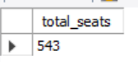

**Q2- -what is the total number of seats available in each state for election?*/**

**Ans 2-**

**Select**

**s.state AS State_name,**

**count(distinct cr.Parliament_Constituency) as Total_seats**

**from Constituencywise_results as cr**

**INNER JOIN statewise_results as sr ON cr.Parliament_Constituency = sr.Parliament_Constituency**

**INNER JOIN States as s ON sr.state_ID = s.state_ID**

**group by s.state;**

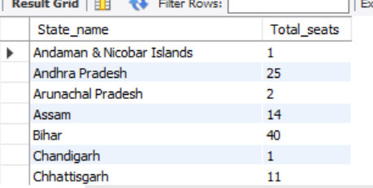

**Q3-** **Total seats won by NDA Alliance**

**select**

**SUM(case**

**when Party IN (**

**'Bharatiya Janata Party - BJP',**

**'Telugu Desam - TDP',**

**'Janata Dal (United) - JD(U)',**

**'Hindustani Awam Morcha (Secular) - HAMS',**

**'Apna Dal (Soneylal) - ADAL',**

**'Lok Janshakti Party(Ram Vilas) - LJPRV',**

**'AJSU Party - AJSUP',**

**'Asom Gana Parishad - AGP',**

**'Janasena Party - JnP',**

**'Janata Dal (Secular) - JD(S)',**

**'Nationalist Congress Party - NCP',**

**'Shiv Sena - SHS',**

**'Sikkim Krantikari Morcha - SKM',**

**'United People Party, Liberal - UPPL',**

**'Rashtriya Lok Dal - RLD'**

**) then Won**

**ELSE 0**

**END) AS NDA_Total_Seats_Won**

**from partywise_results;**

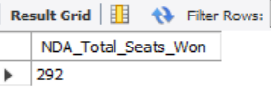

**Q4- Total Individual seats won by each NDA ALLIANCE PARTY**

**select**

**party as Party_Name, Won as Seats_Won**

**from partywise_results**

**where party IN (**

**'Bharatiya Janata Party - BJP',**

**'Telugu Desam - TDP',**

**'Janata Dal (United) - JD(U)',**

**'Hindustani Awam Morcha (Secular) - HAMS',**

**'Apna Dal (Soneylal) - ADAL',**

**'Lok Janshakti Party(Ram Vilas) - LJPRV',**

**'AJSU Party - AJSUP',**

**'Asom Gana Parishad - AGP',**

**'Janasena Party - JnP',**

**'Janata Dal (Secular) - JD(S)',**

**'Nationalist Congress Party - NCP',**

**'Shiv Sena - SHS',**

**'Sikkim Krantikari Morcha - SKM',**

**'United People Party, Liberal - UPPL',**

**'Rashtriya Lok Dal - RLD')**

**ORDER BY Seats_Won DESC;**

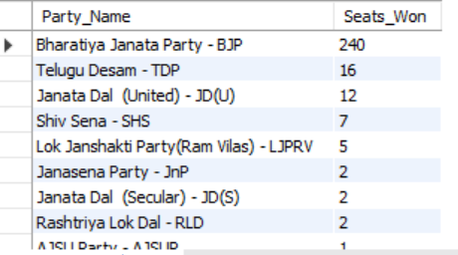

Q5- **Total Seats Won by I.N.D.I.A. Alliance**

select

SUM(case

when Party IN (

'Indian National Congress - INC',

'Aam Aadmi Party - AAAP',

'All India Trinamool Congress - AITC',

'Shiv Sena (Uddhav Balasaheb Thackrey) - SHSUBT',

'Samajwadi Party - SP',

'Dravida Munnetra Kazhagam - DMK',

'Nationalist Congress Party Sharadchandra Pawar - NCPSP',

'Rashtriya Janata Dal - RJD',

'Jharkhand Mukti Morcha - JMM',

'Communist Party of India (Marxist) - CPI(M)',

'Indian Union Muslim League - IUML',

'Jammu & Kashmir National Conference - JKN',

'Communist Party of India - CPI',

'Kerala Congress - KEC',

'Viduthalai Chiruthaigal Katchi - VCK',

'Revolutionary Socialist Party - RSP',

'Marumalarchi Dravida Munnetra Kazhagam - MDMK',

'Communist Party of India (Marxist-Leninist) (Liberation) - CPI(ML)(L)',

'Rashtriya Loktantrik Party - RLTP',

'Bharat Adivasi Party - BHRTADVSIP'

) then Won

else 0

END) AS India_total_seats_won

From partywise_results;

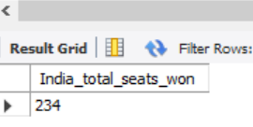

/*6- **Total seats won by each NDA ALLIANCE PARTY**\*/

select

party as Party_Name, Won as Seats_Won

from partywise_results

where party IN (

'Indian National Congress - INC',

'Aam Aadmi Party - AAAP',

'All India Trinamool Congress - AITC',

'Shiv Sena (Uddhav Balasaheb Thackrey) - SHSUBT',

'Samajwadi Party - SP',

'Dravida Munnetra Kazhagam - DMK',

'Nationalist Congress Party Sharadchandra Pawar - NCPSP',

'Rashtriya Janata Dal - RJD',

'Jharkhand Mukti Morcha - JMM',

'Communist Party of India (Marxist) - CPI(M)',

'Indian Union Muslim League - IUML',

'Jammu & Kashmir National Conference - JKN',

'Communist Party of India - CPI',

'Kerala Congress - KEC',

'Viduthalai Chiruthaigal Katchi - VCK',

'Revolutionary Socialist Party - RSP',

'Marumalarchi Dravida Munnetra Kazhagam - MDMK',

'Communist Party of India (Marxist-Leninist) (Liberation) - CPI(ML)(L)',

'Rashtriya Loktantrik Party - RLTP',

'Bharat Adivasi Party - BHRTADVSIP')

order by Seats_Won desc;

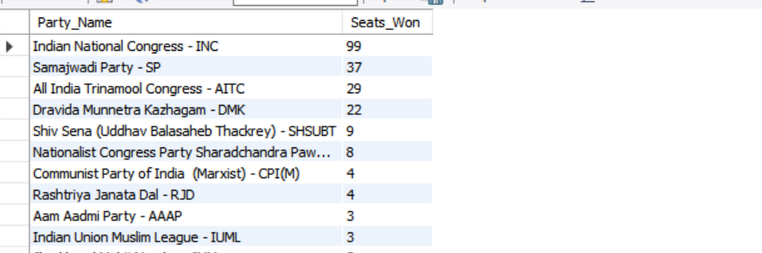

7- Add a new column field in table partywise_results to get the Party Allianz as

NDA, I.N.D.I.A and OTHER */

Alter Table partywise_results

ADD column Party_Alliance varchar(50);

update partywise_results

set Party_Alliance = 'I.N.D.I.A'

WHERE party IN ('Indian National Congress - INC',

'Aam Aadmi Party - AAAP',

'All India Trinamool Congress - AITC',

'Shiv Sena (Uddhav Balasaheb Thackrey) - SHSUBT',

'Samajwadi Party - SP',

'Dravida Munnetra Kazhagam - DMK',

'Nationalist Congress Party Sharadchandra Pawar - NCPSP',

'Rashtriya Janata Dal - RJD',

'Jharkhand Mukti Morcha - JMM',

'Communist Party of India (Marxist) - CPI(M)',

'Indian Union Muslim League - IUML',

'Jammu & Kashmir National Conference - JKN',

'Communist Party of India - CPI',

'Kerala Congress - KEC',

'Viduthalai Chiruthaigal Katchi - VCK',

'Revolutionary Socialist Party - RSP',

'Marumalarchi Dravida Munnetra Kazhagam - MDMK',

'Communist Party of India (Marxist-Leninist) (Liberation) - CPI(ML)(L)',

'Rashtriya Loktantrik Party - RLTP',

'Bharat Adivasi Party - BHRTADVSIP');

update partywise_results

set Party_Alliance = 'N.D.A'

WHERE party in ('Bharatiya Janata Party - BJP',

'Telugu Desam - TDP',

'Janata Dal (United) - JD(U)',

'Hindustani Awam Morcha (Secular) - HAMS',

'Apna Dal (Soneylal) - ADAL',

'Lok Janshakti Party(Ram Vilas) - LJPRV',

'AJSU Party - AJSUP',

'Asom Gana Parishad - AGP',

'Janasena Party - JnP',

'Janata Dal (Secular) - JD(S)',

'Nationalist Congress Party - NCP',

'Shiv Sena - SHS',

'Sikkim Krantikari Morcha - SKM',

'United People Party, Liberal - UPPL',

'Rashtriya Lok Dal - RLD');

update partywise_results

set Party_Alliance = 'OTHERS'

where Party_Alliance is NULL;

set sql_safe_updates = 0;

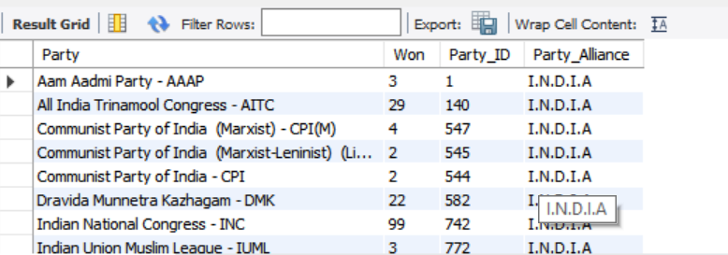

8- Which party alliance (NDA, I.N.D.I.A, or OTHER) won the most seats across

all states? */

SELECT Party_Alliance,

sum(Won) as Total_seats_Won

from Partywise_results

group by Party_Alliance

order by sum(Won) desc;

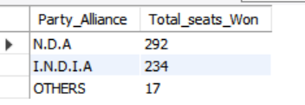

/*ONLY NDA ALLIANZ SEATS */

SELECT Party,

Won as Total_seats_Won

from Partywise_results

where Party_Alliance = 'N.D.A'

order by Won desc;

/*2nd- method - */

select p.Party_Alliance,

count(cr.Constituency_ID) as Seats_Won

from constituencywise_results as cr

inner join partywise_results as p ON cr.Party_ID = p.Party_ID

where p.Party_Alliance IN ('N.D.A', 'I.N.D.I.A', 'OTHERS')

GROUP BY p.Party_Alliance

order by Seats_Won desc;

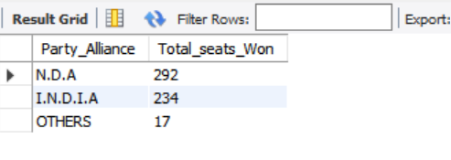

9- Winning candidate's name, their party name, total votes, and the margin of victory for a

specific state and constituency?*/

SELECT cr.Winning_Candidate, p.party, p.Party_Alliance, cr.Total_Votes, cr.Margin, s.state,

cr.Constituency_Name from constituencywise_results as cr

inner join partywise_results p ON cr.Party_ID = p.Party_ID

inner join statewise_results sr ON cr.Parliament_Constituency = sr.Parliament_Constituency

inner join states s ON sr.State_ID = s.State_ID

where s.State = 'West Bengal' AND cr.Constituency_Name = 'KOLKATAUTTAR';



10- What is the distribution of EVM votes versus postal votes for candidates in a

specific constituency?*/

select cd.candidate, cd.Party, cd.EVM_Votes, cd.Postal_Votes,

cd.Total_Votes, cr.Constituency_Name

from constituencywise_details cd

inner join constituencywise_results cr ON cd.Constituency_ID = cr.Constituency_ID

where cr.Constituency_Name = 'JADAVPUR'

order by cd.Total_Votes desc;

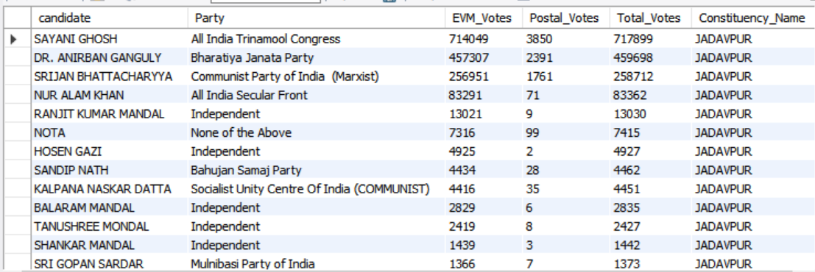

11- Which parties won the most seats in s State, and how many seats did each party win? */

select pr.Party,

count(Constituency_ID) as Seats_Won

from constituencywise_results as cr

inner join Partywise_results pr ON cr.Party_ID = pr.Party_ID

inner join statewise_results sr ON cr.Parliament_Constituency = sr.Parliament_Constituency

inner join states s ON sr.State_ID = s.State_ID

where s.State = 'Andhra Pradesh'

group by pr.Party

order by Seats_Won desc;

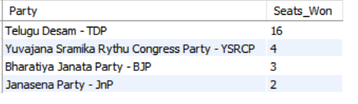

12- What is the total number of seats won by each party alliance (NDA, I.N.D.I.A, and OTHER)

in each state for the India Elections 2024*/

SELECT

s.State AS State_Name,

SUM(CASE WHEN p.party_alliance = 'N.D.A' THEN 1 ELSE 0 END) AS NDA_Seats_Won,

SUM(CASE WHEN p.party_alliance = 'I.N.D.I.A' THEN 1 ELSE 0 END) AS INDIA_Seats_Won,

SUM(CASE WHEN p.party_alliance = 'OTHERS' THEN 1 ELSE 0 END) AS OTHER_Seats_Won

FROM

constituencywise_results cr

JOIN

partywise_results p ON cr.Party_ID = p.Party_ID

JOIN

statewise_results sr ON cr.Parliament_Constituency = sr.Parliament_Constituency

JOIN

states s ON sr.State_ID = s.State_ID

WHERE

p.party_alliance IN ('N.D.A', 'I.N.D.I.A', 'OTHERS') -- Filter for NDA and INDIA alliances

GROUP BY

s.State

ORDER BY

s.State;

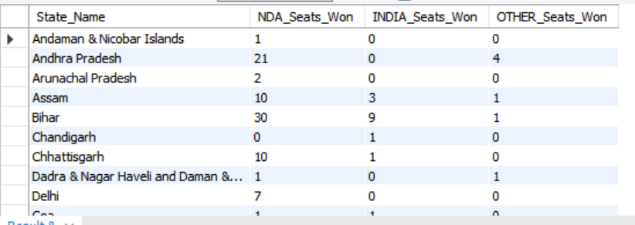

13- Which candidate received the highest number of EVM votes in each constituency (Top 10)?

SELECT cd.Candidate, max(cd.EVM_Votes) as Max_Votes , cr.Constituency_Name, cr.constituency_ID

from constituencywise_details cd

inner join constituencywise_results cr ON cd.Constituency_ID = cr.Constituency_ID

GROUP BY cr.Constituency_Name, cd.Candidate, cr.constituency_ID

order by Max_Votes desc

LIMIT 10;

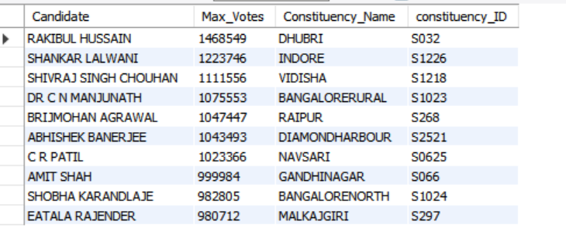

14- Which candidate won and which candidate was the runner-up in each constituency of State for the 2024 elections?*/

WITH RankedCandidates AS (

SELECT

cd.Constituency_ID,

cd.Candidate,

cd.Party,

cd.EVM_Votes,

cd.Postal_Votes,

cd.EVM_Votes + cd.Postal_Votes AS Total_Votes,

ROW_NUMBER() OVER (PARTITION BY cd.Constituency_ID ORDER BY cd.EVM_Votes + cd.Postal_Votes DESC) AS VoteRank

FROM

constituencywise_details cd

JOIN

constituencywise_results cr ON cd.Constituency_ID = cr.Constituency_ID

JOIN

statewise_results sr ON cr.Parliament_Constituency = sr.Parliament_Constituency

JOIN

states s ON sr.State_ID = s.State_ID

WHERE

s.State = 'Maharashtra'

)

SELECT

cr.Constituency_Name,

MAX(CASE WHEN rc.VoteRank = 1 THEN rc.Candidate END) AS Winning_Candidate,

MAX(CASE WHEN rc.VoteRank = 2 THEN rc.Candidate END) AS Runnerup_Candidate

FROM

RankedCandidates rc

JOIN

constituencywise_results cr ON rc.Constituency_ID = cr.Constituency_ID

GROUP BY

cr.Constituency_Name

ORDER BY

cr.Constituency_Name;

2nd Method –

SELECT

cd.Candidate,

cd.Constituency_ID,

cr.Constituency_Name,

sr.State,

cd.EVM_Votes + cd.Postal_Votes AS Total_Votes,

ROW_NUMBER() OVER (PARTITION BY sr.State ORDER BY cd.EVM_Votes + cd.Postal_Votes DESC) AS State_Vote_Rank

FROM

constituencywise_details cd

INNER JOIN

constituencywise_results cr ON cd.Constituency_ID = cr.Constituency_ID

INNER JOIN

statewise_results sr ON cr.Parliament_Constituency = sr.Parliament_Constituency

LIMIT 2;



15- For the state of Maharashtra, what are the total number of seats, number of candidates,

number of parties, total votes (including EVM and postal), and the breakdown of EVM and postal votes?*/

Select s.State,

COUNT(DISTINCT cr.Constituency_ID) as Total_Seats,

COUNT(DISTINCT cd.Candidate) as Total_Candidates,

COUNT(DISTINCT pr.Party) as Total_Party,

SUM(cd.EVM_Votes + cd.Postal_Votes) as Total_Votes,

SUM(cd.EVM_Votes) as Total_EVM_Votes,

SUM(cd.Postal_Votes) as Total_Postal_Votes

from Constituencywise_details cd

inner join Constituencywise_results cr ON cd.Constituency_ID = cr.Constituency_ID

inner join statewise_results sr ON sr.Parliament_Constituency = cr.Parliament_Constituency

Inner join Partywise_results pr ON pr.Party_ID = cr.Party_ID

inner join States s ON sr.State_ID = s.State_ID

where s.State = 'Uttar Pradesh';

